Laporan Tugas Praktikum Pemrograman II

Pertemuan 6



Disusun Oleh :

Rizky Abdurrahman – 223040037

Universitas Pasundan

Fakultas Teknik

Teknik Informatika

* Keseluruhan Kode

import javax.swing.*;

import javax.swing.table.DefaultTableModel;

import java.awt.*;

import java.awt.event.ActionEvent;

import java.awt.event.ActionListener;

public class DataMahasiswaApp extends JFrame {

    private JTextField tfNama;

    private JTextArea taAlamat;

    private JRadioButton rbLaki, rbPerempuan;

    private JCheckBox cbAktif;

    private JComboBox<String> cbJurusan;

    private JList<String> listHobi;

    private JSlider sliderSemester;

    private JSpinner spinnerUsia;

    private JTable table;

    private DefaultTableModel tableModel;

    private JPanel mainPanel;

    private CardLayout cardLayout;

    public DataMahasiswaApp() {

        setTitle("Aplikasi Data Mahasiswa");

        setSize(800, 600);

        setDefaultCloseOperation(JFrame.EXIT_ON_CLOSE);

        setLocationRelativeTo(null);

        // Menu Bar

        JMenuBar menuBar = new JMenuBar();

        JMenu menuFile = new JMenu("File");

        JMenuItem exitItem = new JMenuItem("Exit");

        exitItem.addActionListener(e -> System.exit(0));

        menuFile.add(exitItem);

        JMenu menuForm = new JMenu("Form");

        JMenuItem formMahasiswaItem = new JMenuItem("Form Mahasiswa");

        formMahasiswaItem.addActionListener(e -> cardLayout.show(mainPanel, "formPanel"));

        menuForm.add(formMahasiswaItem);

        JMenu menuView = new JMenu("View");

        JMenuItem viewDataItem = new JMenuItem("View Data");

        viewDataItem.addActionListener(e -> cardLayout.show(mainPanel, "viewPanel"));

        menuView.add(viewDataItem);

        menuBar.add(menuFile);

        menuBar.add(menuForm);

        menuBar.add(menuView);

        setJMenuBar(menuBar);

        // Layout utama menggunakan CardLayout

        cardLayout = new CardLayout();

        mainPanel = new JPanel(cardLayout);

        mainPanel.add(createFormPanel(), "formPanel");

        mainPanel.add(createViewPanel(), "viewPanel");

        add(mainPanel, BorderLayout.CENTER);

        // Tampilkan halaman form di awal

        cardLayout.show(mainPanel, "formPanel");

    }

    private JPanel createFormPanel() {

        JPanel formPanel = new JPanel(new GridLayout(10, 2, 5, 5));

        tfNama = new JTextField();

        taAlamat = new JTextArea(3, 20);

        rbLaki = new JRadioButton("Laki-Laki");

        rbPerempuan = new JRadioButton("Perempuan");

        ButtonGroup bgGender = new ButtonGroup();

        bgGender.add(rbLaki);

        bgGender.add(rbPerempuan);

        cbAktif = new JCheckBox("Aktif");

        cbJurusan = new JComboBox<>(new String[]{"Teknik Informatika", "Sistem Informasi", "Manajemen"});

        listHobi = new JList<>(new String[]{"Membaca", "Olahraga", "Menulis", "Musik"});

        sliderSemester = new JSlider(1, 8, 1);

        spinnerUsia = new JSpinner(new SpinnerNumberModel(18, 17, 30, 1));

        formPanel.add(new JLabel("Nama:"));

        formPanel.add(tfNama);

        formPanel.add(new JLabel("Alamat:"));

        formPanel.add(new JScrollPane(taAlamat));

        formPanel.add(new JLabel("Jenis Kelamin:"));

        JPanel genderPanel = new JPanel();

        genderPanel.add(rbLaki);

        genderPanel.add(rbPerempuan);

        formPanel.add(genderPanel);

        formPanel.add(new JLabel("Status Mahasiswa:"));

        formPanel.add(cbAktif);

        formPanel.add(new JLabel("Jurusan:"));

        formPanel.add(cbJurusan);

        formPanel.add(new JLabel("Hobi:"));

        formPanel.add(new JScrollPane(listHobi));

        formPanel.add(new JLabel("Semester:"));

        formPanel.add(sliderSemester);

        formPanel.add(new JLabel("Usia:"));

        formPanel.add(spinnerUsia);

        JButton btnAdd = new JButton("Tambah");

        btnAdd.addActionListener(e -> addData());

        formPanel.add(btnAdd);

        return formPanel;

    }

    private JPanel createViewPanel() {

        JPanel viewPanel = new JPanel(new BorderLayout());

        JLabel titleLabel = new JLabel("Daftar Mahasiswa", SwingConstants.CENTER);

        titleLabel.setFont(new Font("Serif", Font.BOLD, 24));

        viewPanel.add(titleLabel, BorderLayout.NORTH);

        String[] columnNames = {"Nama", "Alamat", "Jenis Kelamin", "Status", "Jurusan", "Hobi", "Semester", "Usia"};

        tableModel = new DefaultTableModel(columnNames, 0);

        table = new JTable(tableModel);

        JButton btnDelete = new JButton("Hapus");

        btnDelete.addActionListener(e -> deleteData());

        JPanel tablePanel = new JPanel(new BorderLayout());

        tablePanel.add(new JScrollPane(table), BorderLayout.CENTER);

        tablePanel.add(btnDelete, BorderLayout.SOUTH);

        viewPanel.add(tablePanel, BorderLayout.CENTER);

        return viewPanel;

    }

    private void addData() {

        String nama = tfNama.getText();

        String alamat = taAlamat.getText();

        String gender = rbLaki.isSelected() ? "Laki-Laki" : rbPerempuan.isSelected() ? "Perempuan" : "";

        String status = cbAktif.isSelected() ? "Aktif" : "Non-Aktif";

        String jurusan = cbJurusan.getSelectedItem().toString();

        String hobi = String.join(", ", listHobi.getSelectedValuesList());

        int semester = sliderSemester.getValue();

        int usia = (int) spinnerUsia.getValue();

        Object[] rowData = {nama, alamat, gender, status, jurusan, hobi, semester, usia};

        tableModel.addRow(rowData);

        clearForm();

    }

    private void deleteData() {

        int selectedRow = table.getSelectedRow();

        if (selectedRow != -1) {

            tableModel.removeRow(selectedRow);

        }

    }

    private void clearForm() {

        tfNama.setText("");

        taAlamat.setText("");

        rbLaki.setSelected(false);

        rbPerempuan.setSelected(false);

        cbAktif.setSelected(false);

        cbJurusan.setSelectedIndex(0);

        listHobi.clearSelection();

        sliderSemester.setValue(1);

        spinnerUsia.setValue(18);

    }

    public static void main(String[] args) {

        SwingUtilities.invokeLater(() -> {

            DataMahasiswaApp app = new DataMahasiswaApp();

            app.setVisible(true);

        });

    }

}

* Tampilan Form GUI

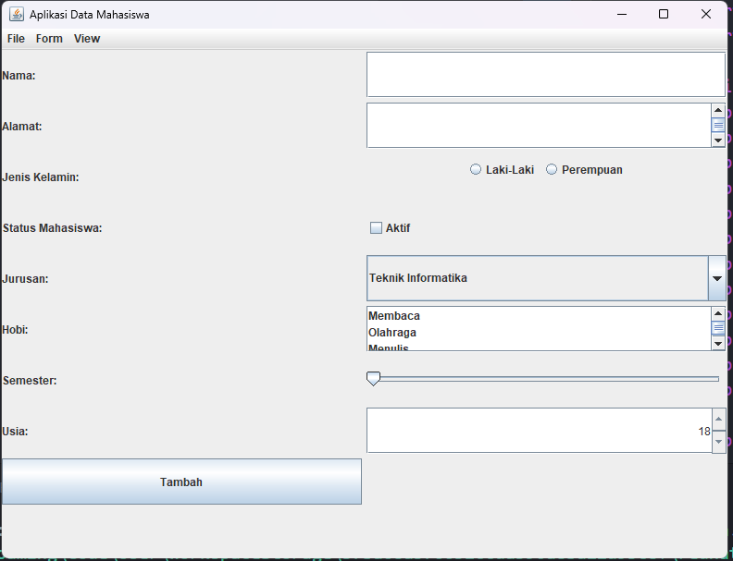

* Pengisian Form

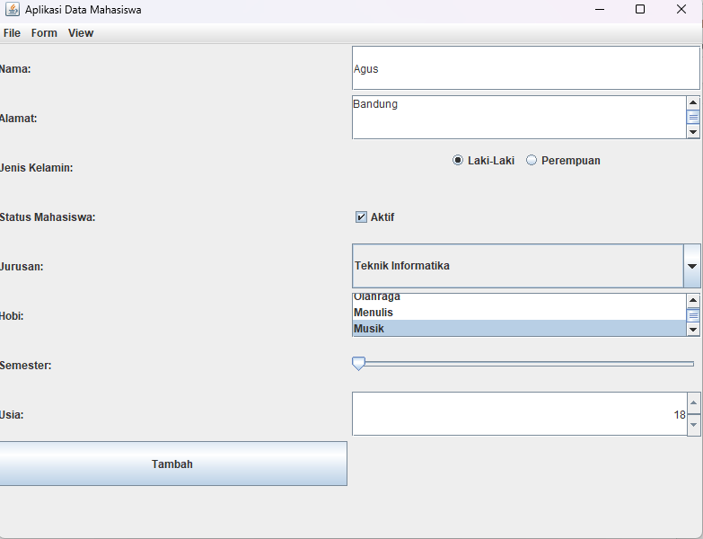

* Perpindahan Halaman Menggunakan JMenu

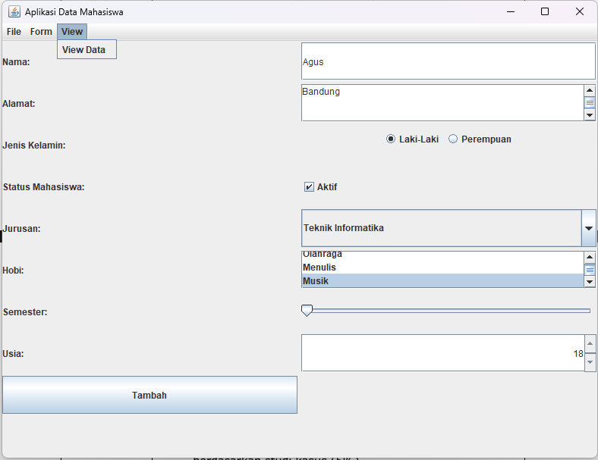

* Tampilan List Mahasiswa, dengan fitur hapus data mahasiswa

